Serverless Development 101

**Module 04 – Developing a Web Application using Serverless Computing**

1/10/2019 Developed by Kevin Wang

1/10/2019 Checked by Clark Jason Ngo

1/10/2019 Tested by Tuan Khai and Minh Truong

2/16/2019 Revised by Sam Chung

Center for Information Assurance (CIAE) @City University of Seattle (CityU)

 

**Learning Outcomes**

* Learn how to serve static content (HTML, CSS, & JavaScript) with Lambda.

Note: with AWS, you have different options to serve static content to your final users by using an EC2 or Lightsail instance with Apache HTTP Server or Nginx, S3, and so forth. In this module, we will introduce an alternative option that is to use a Lambda function in order to build our own web server and serve the static content to users.

**Develop a Web application using an AWS Lambda function**

1. Open the VSCode and open the “myproject” project folder that we created in the previous module.
2. Open the ‘get-index.js’ file under the functions folder.

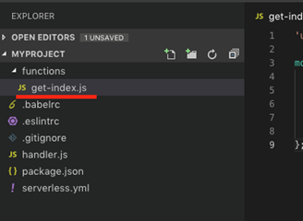 

1. Open <http://bit.ly/2zS0sJw>  and compare it with ‘get-index.js’ file.  
   A new “getHtml” function is added.  
   **Current One**

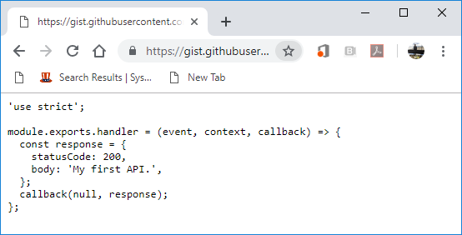  
**New One**  
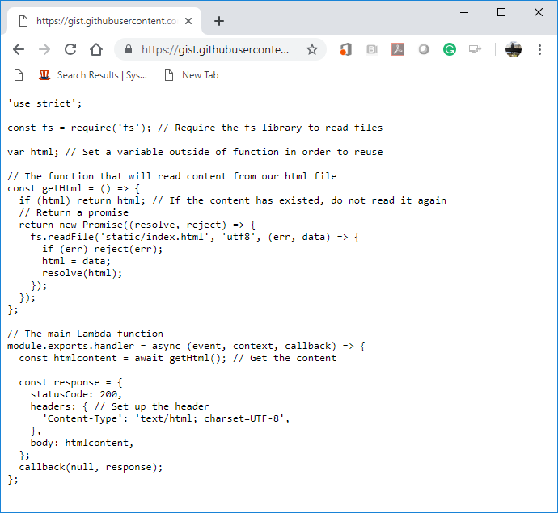

1. Copy the content from <http://bit.ly/2zS0sJw> and replace the old content in the get-index.js.   
   Save your file.
2. Create a new folder under **the root folder** and name it to “static”

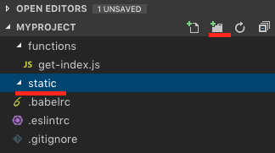

1. Create an “index.html” file in the static folder

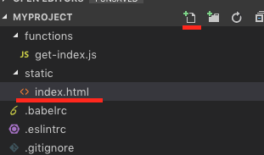 

1. Copy the content from <http://bit.ly/2zPFWcx> to the index.html file.  
   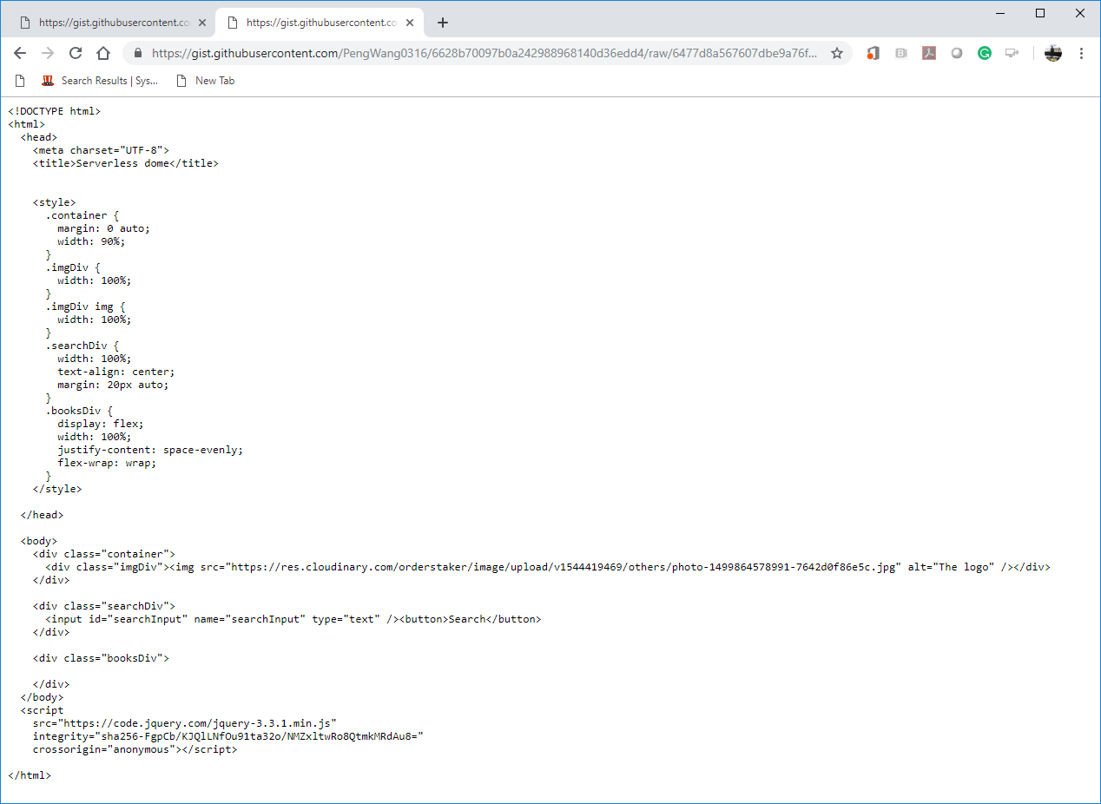
2. Open a terminal (press control and ~ keys) in VSCode and type “sls deploy” to deploy your new function. (**It may take a while based on your network speed**.)

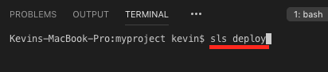 

1. Copy the URL from “endpoints” and put it in the browser to invoke it or press “ctrl+click” to follow link.  
     
   **/var/folders/34/3jns11qs1nd6qd5csswy30mc0000gn/T/com.microsoft.Word/Content.MSO/808520EB.tmp**   
   Note: you will have different URL endpoints.   
   You can see the html content in your browser.  
     
   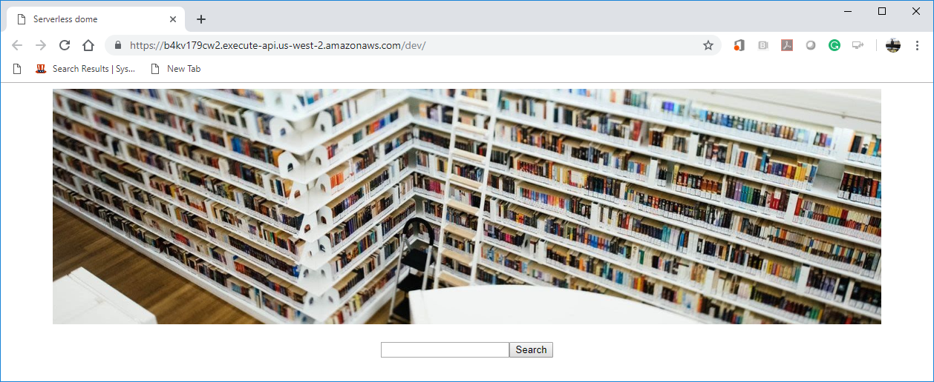

**Questions:**

1. Explain the ‘get-index.js’ file.  
   (Answer)

We use ‘get-index.js’ to read html content from ‘static/index.html’ and display it on the page.

The script has main Lambda function with ‘module.exports.handler’ where we are trying to get an html from ‘getHml’ function and assign that to a variable. If we already built html, we don’t read ‘index.html’ file anymore.

1. Explain the ‘index.html’ file.  
   (Answer)  
   We use Html5 since the declaration of the file is ‘<!DOCTYPE html>’. We also used inline CSS styles to display content on the page. We also added minimized source URL for jQuery library. The page contains multiple ‘div’ elements to display image, search and books.
2. What happened after you run “sls deploy”?  
   Explain how your application works.  
   (Answer)  
   I believe we use ‘sls deploy’ for Mac version. In my case I used ‘serverless deploy’ since I’m working on Windows. Once I run deploy command, my code starts pushing updates on the server at AWS.
3. Where your static content and Lambda function are stored?  
   (Answer)

My Lambda function stored at “AWS Management Console” -> “Lambda” service. I can navigate there using my AWS account.